PRACTICAL 1
- Create different blinking patterns with LEDs by connecting to GPIO pints of Raspberry Pi.

Aim: To display Different LED pattern with raspberry Pi.
Hardware Requirements:
- Raspberry pi
- LEDs
- Resistors
- Jumper wire (Male-Female)
Code:
import RPi.GPIO as GPIO
import time
GPIO.setmode(GPIO.BOARD)
GPIO.setwarnings(False)
GPIO.setup(7,GPIO.OUT)
GPIO.setup(29,GPIO.OUT)
GPIO.setup(31,GPIO.OUT)
GPIO.setup(33,GPIO.OUT)
while(1):
GPIO.output(7,False)
print("LED 1 IS OFF")
time.sleep(1)
GPIO.output(29,False)
print("LED 2 IS OFF")
time.sleep(1.5)
GPIO.output(31,False)
print("LED 3 IS OFF")
time.sleep(2)
GPIO.output(33,False)
print("LED 4 IS OFF")
time.sleep(2.5)
GPIO.output(7,True)
print("LED 1 IS FINALLY ON")
time.sleep(3.5)
GPIO.output(29,True)
print("LED 2 IS FINALLY ON")
time.sleep(4)
GPIO.output(31,True)
print("LED 3 IS FINALLY ON")
time.sleep(4.5)
GPIO.output(33,True)
print("LED 4 IS FINALLY ON")
time.sleep(5)
GPIO.output(7,False)
print("LED 1 IS OFF")
time.sleep(1)
GPIO.output(29,False)
print("LED 2 IS OFF")
time.sleep(1.5)
GPIO.output(31,False)
print("LED 3 IS OFF")
time.sleep(2)
GPIO.output(33,False)
print("LED 4 IS OFF")
time.sleep(2.5)
print("PROGRAM COMPLETE!")
GPIO.cleanup()

Output:

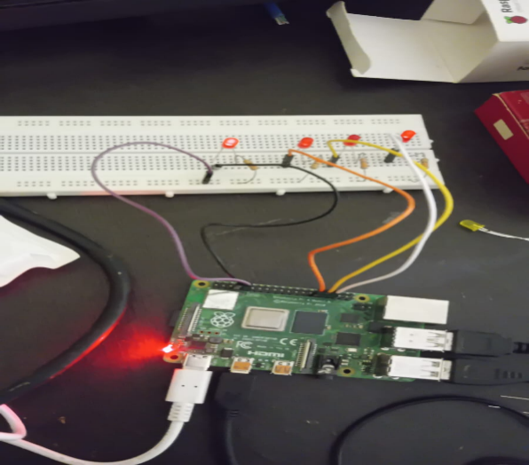
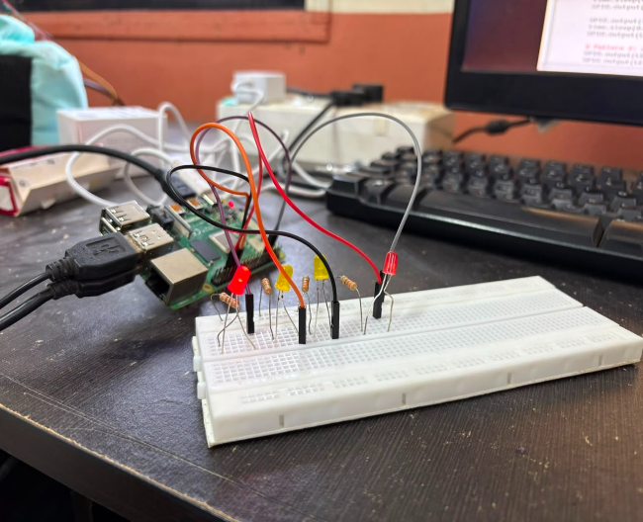

PRACTICAL 2
- Use Telegram to control Raspberry Pi GPIO

Aim: Controlling Raspberry pi using Telegram.
Hardware Requirements:
- Raspberry Pi
- LEDs
- Register
- Breadboard
- Jumper Wire (Male-Female)
- Mobile Phone
Steps to perform on Telegram:
- Install Telegram App On your Smart phone.
- Open Telegram Search for botfather and click on start or type /start.
- Provide a name for your bot
E.g: “tyitIOT”
- Then provide username for your bot. Note that bot must end with _bot.
- After this process the botfather give a token number for accessing, copy pate those token number in the code.
Steps to perform on raspberry command Prompt:
- Sudo apt-update
- Sudo apt-get install python-pip
- Sudo pip install teleport
- Go to python idle3 & open telegram.py (or the folder where you save the code)
Code:
import time, datetime
import RPi.GPIO as GPIO
import telepot
from telepot.loop import MessageLoop
first_led = 7
second_led = 29
third_led = 31
fourth_led = 33
now = datetime.datetime.now()
GPIO.setmode(GPIO.BOARD)
GPIO.setwarnings(False)
#LED first_led
GPIO.setup(first_led, GPIO.OUT)
GPIO.output(first_led, 0) #Off initially
#LED second_led
GPIO.setup(second_led, GPIO.OUT)
GPIO.output(second_led, 0) #Off initially
#LED third_led
GPIO.setup(third_led, GPIO.OUT)
GPIO.output(third_led, 0) #Off initially
##LED fourth_led
GPIO.setup(fourth_led, GPIO.OUT)
GPIO.output(fourth_led, 0) #Off initially
def action(msg):
chat_id = msg['chat']['id']
command = msg['text']
print ('Received: %s' % command)
if 'on' in command:
message = "on"
if 'first_led' in command:
message = message + "first_led"
GPIO.output(first_led, 1)
if 'second_led' in command:
message = message + "second_led"
GPIO.output(second_led, 1)
if 'third_led' in command:
message = message + "third_led"
GPIO.output(third_led, 1)
if 'fourth_led' in command:
message = message + "fourth_led"
GPIO.output(fourth_led, 1)
if 'all' in command:
GPIO.output(first_led, 1)
GPIO.output(second_led, 1)
GPIO.output(third_led, 1)
GPIO.output(fourth_led, 1)
message = message + "light(s)"
telegram_bot.sendMessage (chat_id, message)
if 'off' in command:
message = "off "
if 'first_led' in command:
message = message + "first_led"
GPIO.output(first_led, 0)
if 'second_led' in command:
message = message + "second_led"
GPIO.output(second_led, 0)
if 'third_led' in command:
message = message + "third_led"
GPIO.output(third_led, 0)
if 'fourth_led' in command:
message = message + "fourth_led"
GPIO.output(fourth_led, 0)
if 'all' in command:
message = message + "all"
GPIO.output(first_led, 0)
GPIO.output(second_led, 0)
GPIO.output(third_led, 0)
GPIO.output(fourth_led, 0)
message = message + "light(s)"
telegram_bot.sendMessage (chat_id, message)
telegram_bot = telepot.Bot('1993353550:AAHT4l_R0YXCsanE0MtOGLtMPy4mQEMMtY0')
print (telegram_bot.getMe())
MessageLoop(telegram_bot, action).run_as_thread()
print ('Up and Running....')
while 1:
time.sleep(10)
Output:
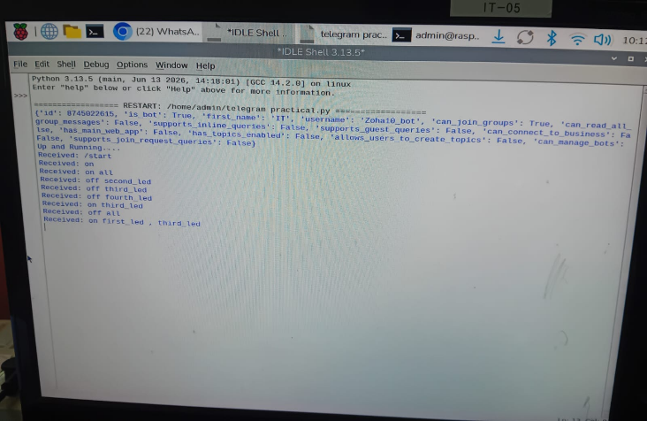
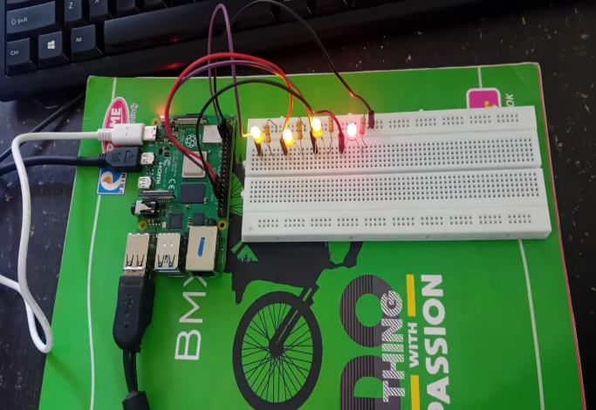

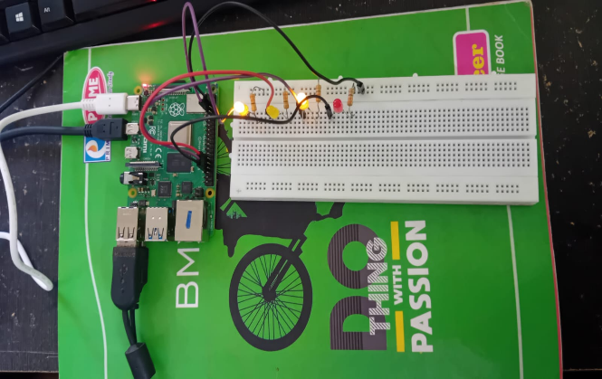
PRACTICAL 3
- Interface Pi Camera with Raspberry Pi to capture image and video.
Aim: Capturing image with Raspberry Pi and Pi camera.
Hardware Requirements:
- Raspberry pi
- Pi Camera
Note:
1. Start the Raspberry Pi.
2. Open the Raspberry Pi Configuration tool from the main menu.
3. Enable the camera software if it is disabled.
4. Reboot the Raspberry Pi to apply the changes.
5. The camera can also be enabled using the command:
"sudo raspi-config"
Commands to download pi camera libraries:
- Sudo apt-get install python3_pip
- Pip3 install picamera
- Then go to python environment & then open picam5 (or the folder where you save the code).
Code:
from picamera2 import Picamera2
import time
picam2 = Picamera2()
picam2.configure(picam2.create_video_configuration())
output_path = "/home/admin/Desktop/ty7.jpg"
try:
picam2.start_recording(output_path)
print("Recording started...")
time.sleep(5) # record 5 seconds
finally:
picam2.stop_recording()
picam2.close() # release camera safely
print("Camera released, recording saved:", output_path)

Output:
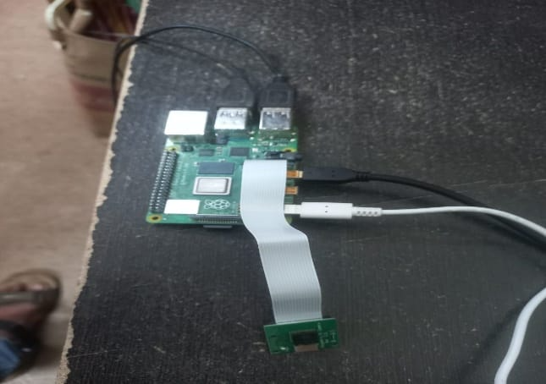
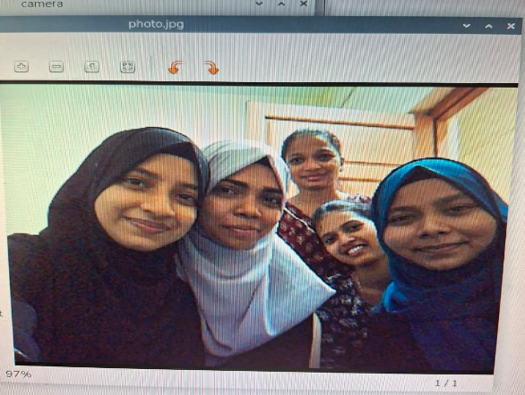

PRACTICAL 4
- Write a Python program to display time on a 4-digit 7-segment display using Raspberry Pi.
Aim: To display time over a 4-digit 7-segment display using Raspberry Pi.
Hardware Requirements:
- Raspberry Pi
- TM1637-4-digit 7-segment display board
- Female to female jumping wires
Connections:
Raspberry Pi | 4-digit 7-segment
Pin2(5V) | Vcc pin
Pin6 (GND) | GND pin
Pin38 | DIO
Pin40 | CLK

Note:
- To download the libraries open web browser on your Raspberry Pi and log on to the following link:
http://github.com/timwaizenegger/raspberrypi-example/tree/master/actor-led-7-segment-4numbers
- Click on the actor-led-7segment-4numbers zip folders and now click on download button to download the file.
- Now on your RPi move to /home/pi/Download.
- Unzip the file and try to execute different example codes present in the folder.
- Open python2 IDLE-create a new file-write the code given and save it in the same folder i.e. actor-led-7segment-4numbers since the code depends on tm1637.py

Code:
#!/usr/bin/env python
# -*- coding: utf-8 -*-
from time import sleep
impor tm1637
try:
import thread
except ImportError:
import _thread as thread
#Initialization the clock (GND, VCC=3.3V, Example pins are DIO-20 and CLK21)
Display = tm1637.TM1637(CLK=21, DIO=20, brightness=1.0)
try:
print("Starting clock in the background press CTRL + C to stop:")
Display.StartClock(military_time=False)
Print("Continue Python Script and tweak Display!")
sleep(5)
Display.ShowDoublepoint(False)
sleep(5)
loops = 3
while loops > 0:
for i in range(0, 10):
Display.setBrightness(i/ 10.0)
sleep(0.5)
loops -= 1
Display.StopClock()
thread.interrupt_main()
except keyboardInterrupt:
print("Properly closing the clock and open GPIO pins")
Display.cleanup()

Output:
